Dhandeaka Harris-Kearse
Southern New Hampshire University
CS 255: Systems Analysis and Design
Prof. Joshua Shawkey
April 19, 2026

UML Diagrams

UML Use Case Diagram
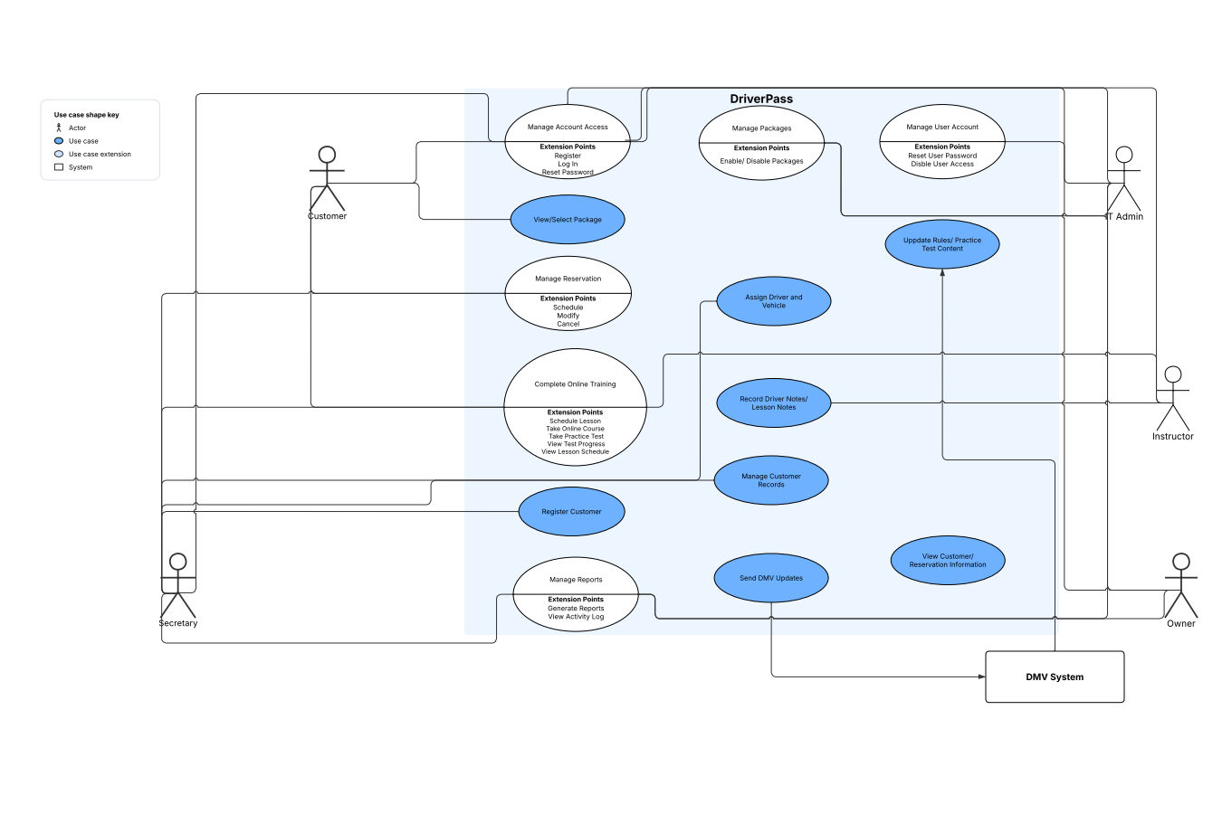

UML Activity Diagrams
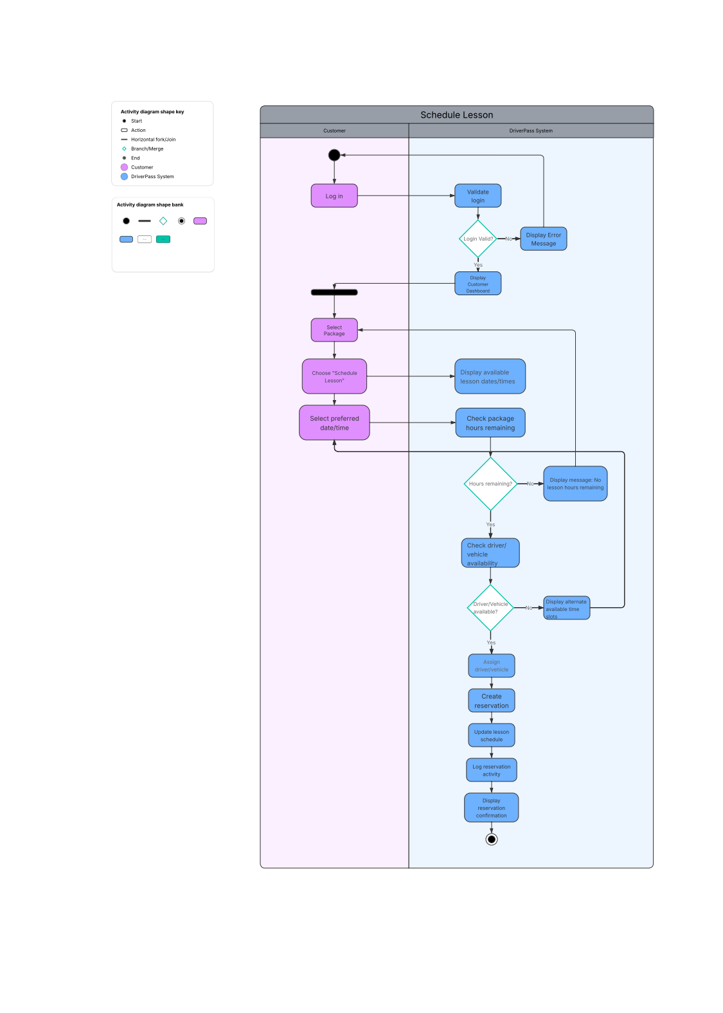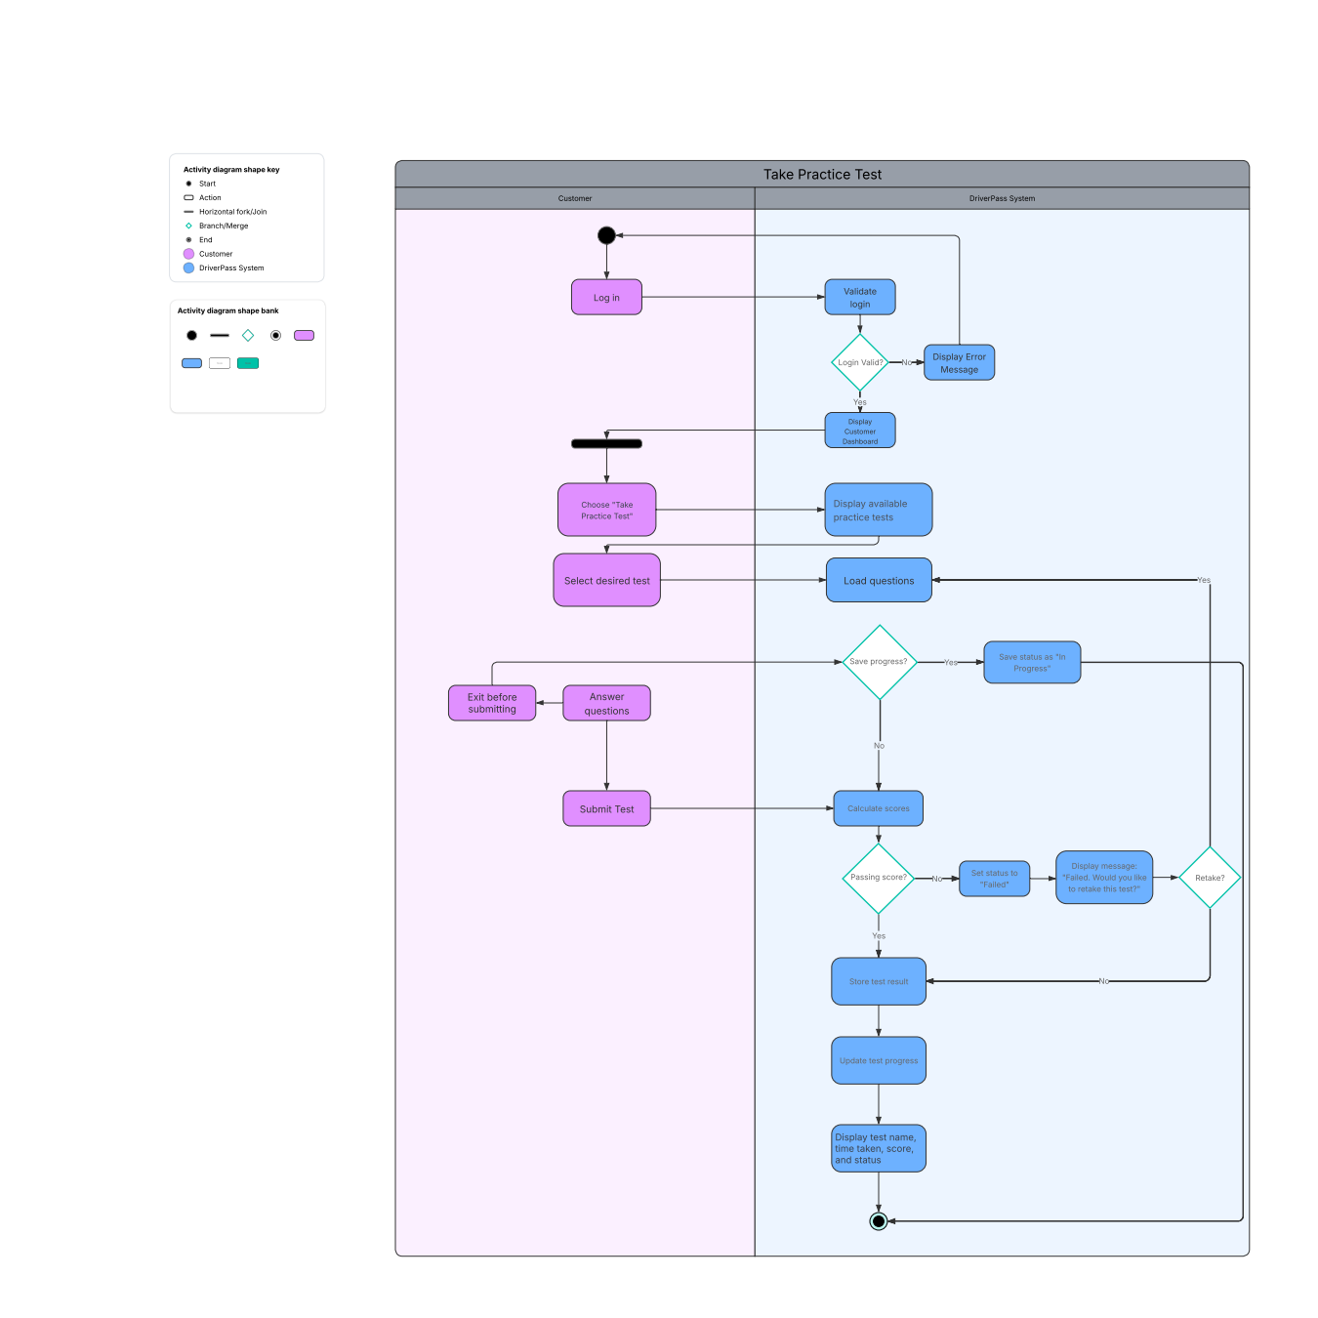

UML Sequence Diagram
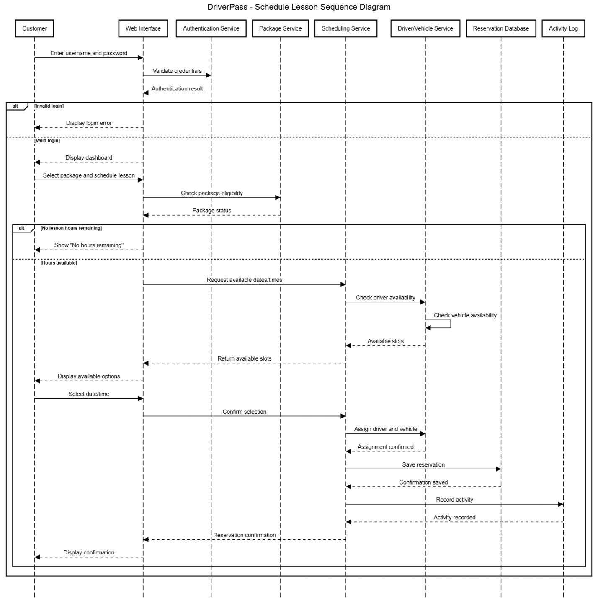

UML Class Diagram
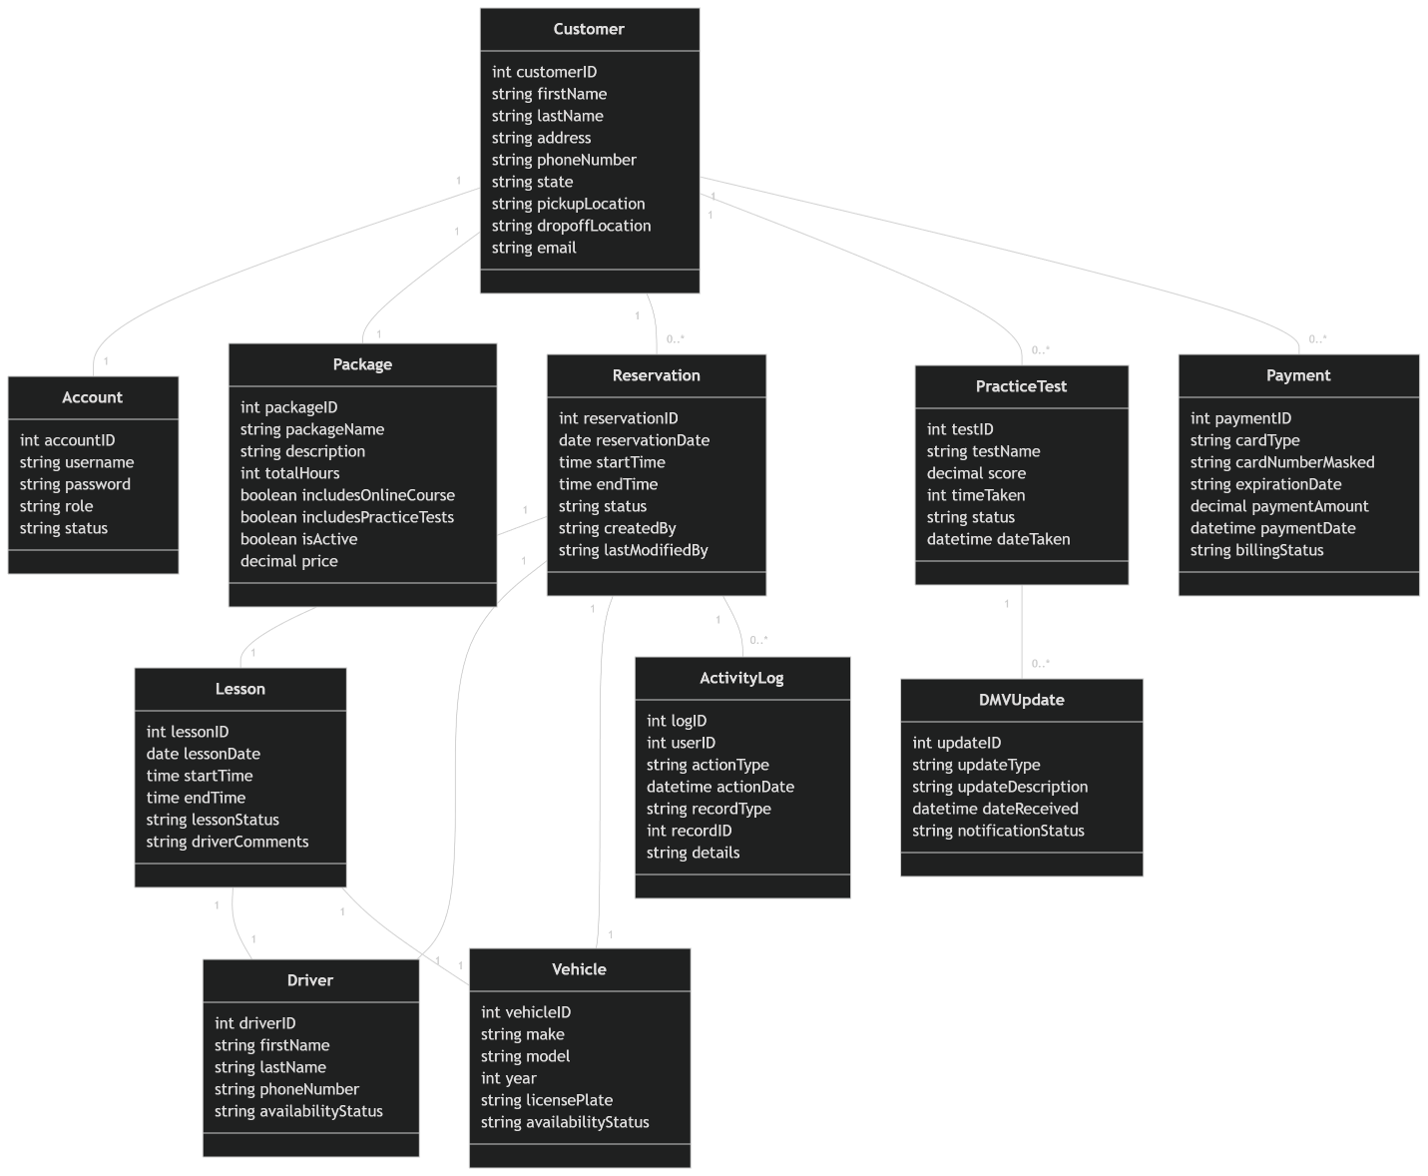

Technical Requirements
The DriverPass system requires a combination of hardware, software, and infrastructure to support its functionality.
Hardware Requirements
The system must support access from multiple devices, including desktop computers, laptops, tablets, and smartphones. Since the system is web-based, users only need an internet-enabled device with a browser. On the backend, cloud-based servers will host the application and database.
Software Requirements
The system will operate as a web-based application accessible through modern browsers such as Chrome, Edge, or Safari. The backend can be developed using programming languages such as Java or Python, while the database can be managed using systems such as MySQL or PostgreSQL. Additional tools may include frameworks for web development and APIs for integration with external systems like the DMV.
Infrastructure Requirements
The system will be hosted in a cloud environment, which ensures scalability, reliability, and accessibility. Cloud hosting allows users to access the system from anywhere while reducing the need for on-site infrastructure. The system must also include database management systems and secure communication protocols.
Security Requirements
Security is a critical component of the system. Users must authenticate with a username and password before accessing the system. Role-based access control ensures that users can only perform actions appropriate to their role. Sensitive data, such as personal and payment information, must be encrypted. The system must also track user activity to monitor changes and maintain accountability.
Performance Requirements
The system should load quickly and handle multiple users simultaneously without performance degradation. It must provide real-time updates for scheduling and availability. Regular system updates should be implemented to ensure accuracy and reliability.
Scalability and Flexibility
The system should be designed to accommodate future growth, including the addition of new packages or features. Administrators should be able to enable or disable packages without modifying the system’s core functionality.

